**KUBERNETES PROJECT**

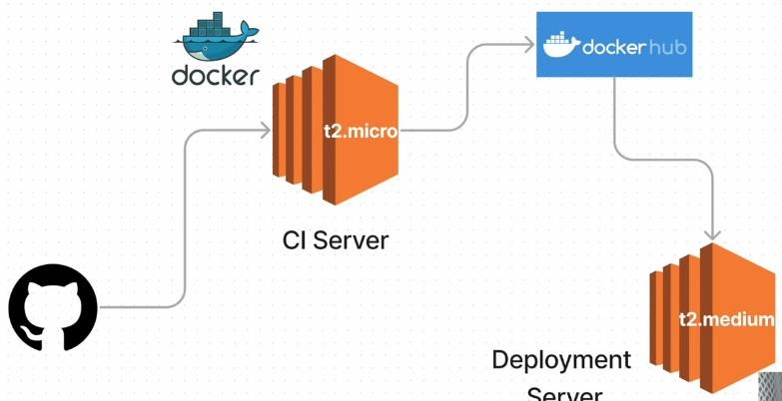

**Step 1:** Clone the source code

**Step 2:** Containerize the Application using Docker

**Step 3:** Building Docker-Image

**Step 4:** Push the Image To DockerHub

**Step 5:** Write a Kubernetes Manifest File

Write Deployment.yml file

Write Service.yml file

**Step 6:** Deploy the app to Kubernetes & Create a Service For It

**Step 7:** Let's Configure Ingress

Ingress:

**Step 8:** Expose the app Test Ingress **prerequisites installed**:

EC2 ( AMI- Ubuntu, Type- t2.medium and t2.xlarge)

Docker

Minikube

Kubectl

**# For Docker Installation**

sudo apt-get update sudo apt-get install docker.io -y sudo usermod -aG docker $USER && newgrp docker

 **clone the source code**

git clone https://github.com/Milky19/reddit-clone-k8s-ingress.git

**build the docker image**

 Push the Image To DockerHub

 Now login to Deployment server and install docker and kubernetes

Curl -L[O https://storage.googleapis.com/minikube/releases/latest/minikube-linux-amd64](https://storage.googleapis.com/minikube/releases/latest/minikube-linux-amd64) Sudo install minikube-linux-amd64 /usr/local/bin/minikube

Sudo snap install kubectl –classic

Minikube start –driver=docker

**Write a Kubernetes Manifest File**

**Deployement.yml**

|  |
| --- |
| **apiVersion: apps/v1 kind: Deployment metadata:**  **name: reddit-clone-deployment labels:**  **app: reddit-clone spec:**  **replicas: 2 selector: matchLabels:**  **app: reddit-clone template: metadata: labels:** |
| **app: reddit-clone spec: containers:**   * **name: reddit-clone image: hanvitha/reddit-clone ports:** * **containerPort: 3000** |

**Servirce.yml**

|  |
| --- |
| **apiVersion: v1 kind: Service metadata:**  **name: reddit-clone-service labels:**  **app: reddit-clone spec:**  **type: NodePort ports: - port: 3000 targetPort: 3000 nodePort: 31000 selector:**  **app: reddit-clone** |

* **Deploy the app to Kubernetes & Create a Service For It**
* **kubectl apply -f Deployment.yml**
* **kubectl apply -f Service.yml**
* **kubectl get deployment & kubectl get services**

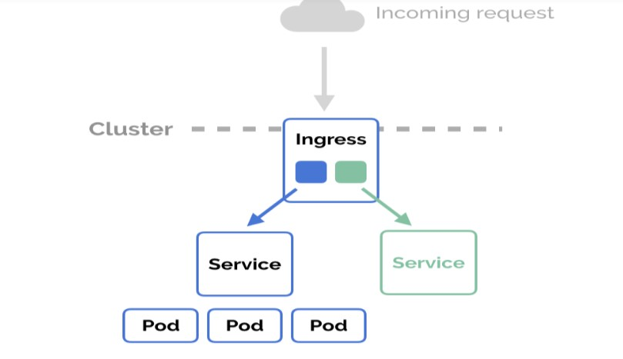

**ingress.yml**

|  |
| --- |
| **apiVersion: networking.k8s.io/v1 kind: Ingress metadata:**  **name: ingress-reddit-app spec: rules:**   * **host: "domain.com"**   **http: paths:**   * **pathType: Prefix path: "/test" backend: service:**   **name: reddit-clone-service** |
| **port:**  **number: 3000**   * **host: "*.domain.com"**   **http: paths:**   * **pathType: Prefix path: "/test" backend: service: name: reddit-clone-service**   **port:**  **number: 3000** |

minikube addons enable ingress minikube addons list command. kubectl apply -f ingress.yml kubectl get ingress ingress-reddit-app

**Expose the app**

kubectl expose deployment reddit-clone-deployment --type=NodePort curl -L <URL> kubectl port-forward svc/reddit-clone-service 3000:3000 --address 0.0.0.0 &

You can also see the deployed application on Ec2_ip:3000

